1. Mod manage event

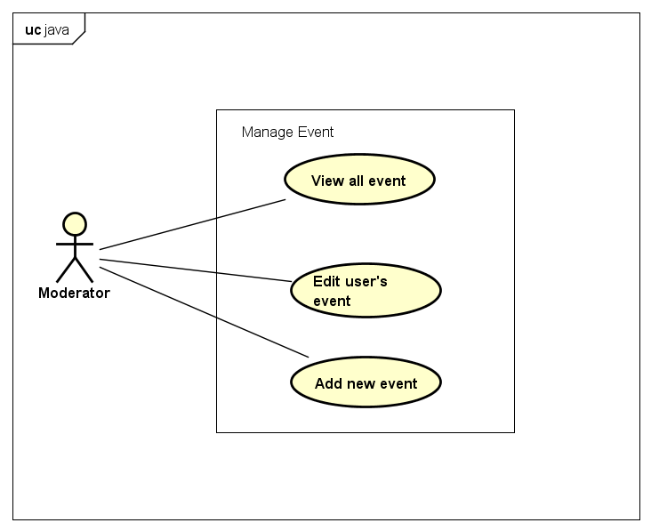

1.1. View all event

|  |  |  |  |  |
| --- | --- | --- | --- | --- |
| Use Case Name | View All Event | | | |
| Use Case ID | UC-1 | | | |
| Created By | CuongNV | **Last Updated By** | | CuongNV |
| Date Created | 22/09/2015 | **Date Last Updated** | | 28/09/2015 |
| Actor | Moderators | | | |
| Goal/Description | This use case allow Moderator views all events in system. | | | |
| Pre-Condition | Moderator logs in to Event Zone. | | | |
| Trigger | Moderator wants to view all events in Event Zone’s system. | | | |
| Basic Path | Actor’s Action | | System’s response | |
|  | 1. Actor click on button setting in the right top website | | Shows user’s Menu | |
| 1. Actor click on Manage Event | | Redirects to Manage Event Page, and shows all events in the system | |
| Alternative Paths | N/A | | | |
| Exception Paths | N/A | | | |
| Post Condition | System redirects to Manage Event Page and shows all event in the system | | | |
| Notes |  | | | |

1.2 Edit event

|  |  |  |  |  |  |
| --- | --- | --- | --- | --- | --- |
| Use Case Name | Edit User’s Event | | | | |
| Use Case ID |  | | | | |
| Created By | CuongNV | | **Last Updated By** | | CuongNV |
| Date Created | 22/09/2015 | | **Date Last Updated** | | 28/09/2015 |
| Actor | Moderators | | | | |
| Goal/Description | This use case allow Moderator edits content of user’s event. | | | | |
| Pre-Condition | Actor logins website as Moderators. System current shows an event or list of events in current screen. | | | | |
| Trigger | Moderator want to edit user’s event in Event Zone’s system. | | | | |
| Basic Path | Actor’s Action | | | System’s response | |
| 1. Actor click on button “Edit” in the right top of event’s thumbnail in the current screen.   *There is an alternative path: A1* | | | Redirects to edit’s event page. | |
| 1. Actor updates fields of event and click on button “Save”.   *There are exception paths: E1, E2* | | | System displays edit confirmation pop-up. | |
| 1. Actor select button “Yes”.   *There is exception path: E4* | | | System update fields of event and save to database. System also determines that this event is last edited by this actor. System informs to user that update successful and redirect to view detail event page of edited event. | |
| Alternative Paths | **A1.** | Actor’s Action | | System’s response | |
| 1. Click on button edit “Edit” in the right top of event. | | Redirects to edit’s event page. | |
| 2. Go to Step 2 in Basic Path. | |  | |
| Exception Paths |  | Actor’s Action | | System’s response | |
| **E1.** | 2. Actor click on button “Cancel” | | System displays exit edit confirmation pop-up. | |
| 3. Actor select button “Yes” | | System redirect to previous page of actor. | |
| **E2** | 2. Actor don’t fill the event title field and click on button “Save” | | System reloads page and shows notice “Event Location cannot empty”. | |
| **E3** | 2.Actor don’t fill the event location’s field and click on button “Save” | | System reloads page and shows the notice “Event Location cannot empty”. | |
| **E4.** | Actor’s Action | | System’s response | |
| 1. Actor select button “No” | | Redirects to edit’s event page. | |
| 2. Go to Step 2 in Basic Path. | | System redirect to previous page of actor. | |
| Post Condition | If basic or alternative path is successful, system redirect to view detail event page of edited event.  If exception are thrown, the result must match with output of each described exception. | | | | |
| Notes |  | | | | |

1.3 Add new event

|  |  |  |  |  |  |
| --- | --- | --- | --- | --- | --- |
| Use Case Name | Add new event | | | | |
| Use Case ID |  | | | | |
| Created By | CuongNV | | **Last Updated By** | | CuongNV |
| Date Created | 22/09/2015 | | **Date Last Updated** | | 28/09/2015 |
| Actor | Moderator | | | | |
| Goal/Description | This use case allow Moderator adds an verify event. | | | | |
| Pre-Condition | Actor logged in to website as Moderator. Actor current access to the Manage event page. | | | | |
| Trigger | Actor determines add verify event. | | | | |
|  | Actor’s Action | | | System’s Response | |
| Basic Path | 1. Click to button Add new event | | | Redirect to mod’s add new event page. | |
| 1. Fill all mandatory fields and click on button “Create”   *There are exception paths: E1,*  *E2, E3, E4, E5* | | | System displays add new event confirmation pop-up. | |
| 1. Actor select button “Yes”.     *There is exception path: E6* | | | System save new event to database. System informs to Actor that add new event successful and redirect to view detail event page new event. | |
| Alternative Paths | **N/A** | | | | |
| Exception Paths | **E1.** | Actor’s Action | | System’s response | |
| 2. Actor click on button “Cancel” | | System displays exit add new event confirmation pop-up. | |
| 3. Actor select button “Yes” | | System redirect to previous page of actor. | |
| **E2.** | 2. Actor don’t fill the event title field and click on button “Create” | | System reloads page and shows notice “Event title cannot empty and must be contain only alphabet or number character.” | |
| **E3.** | 2. Actor don’t select the Event’s start date and click on button “Create” | | System reloads page and shows notice “Please select time to start event” | |
| **E4.** | 2. Actor don’t fill the event location field and click on button “Create” | | System reloads page and shows notice “Event’s location cannot empty” | |
| **E5.** | 2. Selects option create live stream but his/her YouTube account is not verified account | | System reloads page and shows notice “Your YouTube account must be verified account to use create live stream feature” | |
| **E6.** | Actor’s Action | | System’s response | |
| 1. Actor select button “No” | | Pop-up is closed. | |
| 2. Go to Step 2 in Basic Path. | |  | |
| Post Condition | If basic path is successful, new event is created in database. System redirect to view detail event page of new event.  If exception are thrown, the result must match with output of each described exception. | | | | |
| Notes |  | | | | |

1. Manage Violation report

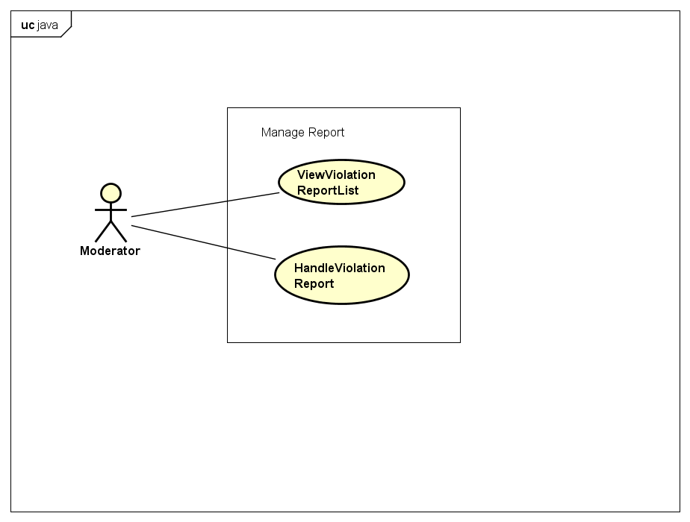

2.1 View report list

|  |  |  |  |  |
| --- | --- | --- | --- | --- |
| Use Case Name | ViewViolationReportList | | | |
| Use Case ID |  | | | |
| Created By | CuongNV | **Last Updated By** | | CuongNV |
| Date Created | 22/09/2015 | **Date Last Updated** | | 23/09/2015 |
| Actor | Moderator | | | |
| Goal/Description | This use case allow Moderator views all violation reports in system. | | | |
| Pre-Condition | Actor logged in to website as Moderator. | | | |
| Trigger | Actor wants to view all reports in the system. | | | |
|  | Actor’s Action | | System’s Response | |
| Basic Path | 1. Actor click on button setting in the right top website | | Shows user’s Menu | |
| 1. Actor click on Manage Report | | Redirects to Manage Reports Page, and shows all events in the system | |
| Alternative Paths | N/A | | | |
| Exception Paths | N/A | | | |
| Post Condition | System redirects to Manage Report Page and shows all reports in the system. | | | |
| Notes |  | | | |

2.2Handle violation report

|  |  |  |  |  |  |
| --- | --- | --- | --- | --- | --- |
| Use Case Name | Handle Violation Report | | | | |
| Use Case ID |  | | | | |
| Created By | CuongNV | | **Last Updated By** | | CuongNV |
| Date Created | 22/09/2015 | | **Date Last Updated** | | 28/09/2015 |
| Actor | Moderators | | | | |
| Goal/Description | This use case allow Moderator handles user’s report. | | | | |
| Pre-Condition | Actor logins website as Moderators. System current shows Manage Reports Page. | | | | |
| Trigger | Moderator want to handle violation report in Event Zone’s system. | | | | |
| Basic Path | Actor’s Action | | | System’s response | |
| 1. Actor selects a pending report from list report. | | | Redirects to view report detail. | |
| 1. Actor click on button “Approve” in the report   *There is an alternative path: A1*  *There is an exception path: E1* | | | System change report status to “Approved” and hidden both button “Approve” and “Reject”. System sends message to report’s sender that his action is approved, and inform to report’s receiver that his event violate system’s privacy. Violation event which is reported in this report is locked. The report’s detail page is reloaded. | |
| Alternative Paths | **A1.** | Actor’s Action | | System’s response | |
| 2. Click on button “Reject” in the report | | System change report status to “Reject” and hidden both button “Approve” and “Reject”. System sends message to report’s sender that his action is rejected. The report’s detail page is reloaded. | |
| Exception Paths | **E1.** | Actor’s Action | | System’s response | |
| 2. Actor click on button “Back to violation report list” | | Redirect to Manage violation reports page. | |
| Post Condition | If basic path is successful, system changes report status and reloads the report’s detail page.  If exception are thrown, the result must match with output of each described exception. | | | | |
| Notes | There are 3 status of report:   * “Pending” report: report is not handled. * “Approved” report: report is determined that the information given in the report is exactly and it must be handle. * “Reject” report: report determined that the information given in the report is not true and it will be ignore. | | | | |

3 Manage Appeal

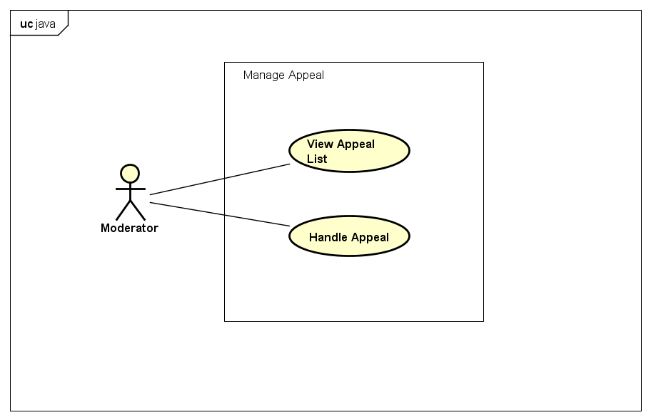

3.1 View Appeal List

|  |  |  |  |  |
| --- | --- | --- | --- | --- |
| Use Case Name | ViewAppealList | | | |
| Use Case ID |  | | | |
| Created By | CuongNV | **Last Updated By** | | CuongNV |
| Date Created | 23/09/2015 | **Date Last Updated** | | 28/09/2015 |
| Actor | Moderator | | | |
| Goal/Description | This use case allow Moderator views all appeals of reports in system. | | | |
| Pre-Condition | Actor logged in to website as Moderator. | | | |
| Trigger | Actor wants to view all reports in the system. | | | |
| Basic Path | Actor’s Action | | System’s Response | |
| 1. Actor click on button setting in the right top website | | Shows user’s Menu | |
| 1. Actor click on Manage Appeal | | Redirects to Manage Appeal Page, and shows all appeal in the system | |
| Alternative Paths | N/A | | | |
| Exception Paths | N/A | | | |
| Post Condition | System redirects to Manage Appeal Page and shows all appeal in the system | | | |
| Notes |  | | | |

3.2 Handle Appeal

|  |  |  |  |  |  |
| --- | --- | --- | --- | --- | --- |
| Use Case Name | HandleAppeal | | | | |
| Use Case ID |  | | | | |
| Created By | CuongNV | | **Last Updated By** | | CuongNV |
| Date Created | 23/09/2015 | | **Date Last Updated** | | 28/09/2015 |
| Actor | Moderator | | | | |
| Goal/Description | This use case allow Moderator handle appeal of reports in system. | | | | |
| Pre-Condition | Actor logins website as Moderators. System current shows Manage Appeal Page. | | | | |
| Trigger | Moderator want to handle appeal in Event Zone’s system. | | | | |
| Basic Path | Actor’s Action | | | System’s Response | |
| 1. Actor selects pending appeal from list appeal. | | | Redirects to view appeal detail. | |
| 1. Actor click on button “Approve” in the report   *There is an alternative path: A1*  *There is an exception path: E1* | | | System change report status to “Approved” and hidden both button “Approve” and “Reject”. System sends message to appeal’s sender that his action is approved. Reported event which is related to this appeal is set to unlocked. The appeal’s detail page is reloaded. | |
| Alternative Paths | **A1.** | Actor’s Action | | System’s response | |
| 2. Actor click on button “Reject” in the appeal | | System change appeal status to “Reject” and hidden both button “Approve” and “Reject”. System sends message to appeal’s sender that his action is rejected. The appeal’s detail page is reloaded. | |
| Exception Paths | **E1.** | Actor’s Action | | System’s response | |
| 2. Actor click on button “Back to appeal list” | | Redirect to Manage appeal page. | |
| Post Condition | If basic path is successful, system updates appeal’s status and reported event’s status, reload appeal’s detail page.  If exception are thrown, the result must match with output of each described exception. | | | | |
| Notes |  | | | | |

4 View Statistic

|  |  |  |  |  |
| --- | --- | --- | --- | --- |
| Use Case Name | View Statistic | | | |
| Use Case ID |  | | | |
| Created By | CuongNV | **Last Updated By** | | CuongNV |
| Date Created | 22/09/2015 | **Date Last Updated** | | 28/09/2015 |
| Actor | Moderator | | | |
| Goal/Description | This use case allow Moderators view statistics about their actions in website, overview about number of users, video, reports… | | | |
| Pre-Condition | Actor logged in to website as Moderator. | | | |
| Trigger | Actor want to view his/her actions in website, view overall website. | | | |
| Basic Path | Actor’s Action | | System’s Response | |
| 1. Actor click on button setting in the right top website | | Shows user’s Menu | |
| 1. Actor click on View Statistic | | Redirects to Mod’s Statistic Page, and shows all overall statistics of the website via graph and numbers. | |
| Alternative Paths | N/A | | | |
| Exception Paths | N/A | | | |
| Post Condition | The system redirects to mod’s statistic page, shows graphs and statistics about website and record of Moderator’s actions. | | | |
| Notes |  | | | |